Mean Reversion Python Script

Data input:

CSV file with dates and prices (order is old data at the top, new data at the bottom)

readdata('USdata.csv',date=0,inp_1=1,inp_2=2,inp_3=3)

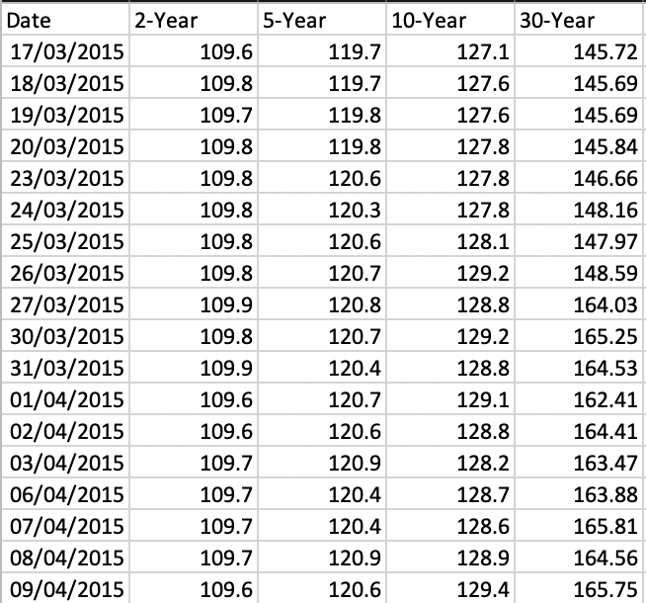readdata function inputs: CSV file path, column location for output 1, column location for output 2, column location for output 3 (optional)

Belly goes first, then wings

Back test:

back_test_RV(date,fives,twos,tens)

back_test_RV function inputs: dates, x, y, z (optional – only for three legs)

Stop loss Z Score

Maximum entry Z Score

Entry Z Score

Exp moving average

Take profit Z Score

back_test_RV optional inputs:

* entry_z = XXX (blue arrow)
* stoploss_z = XXX (red arrow)
* takeprofit_z = XXX (green arrow)
* maxentry_z = XXX (orange dotted line)
* com = XXX exponential moving average weight
* window = XXX lookback window used
* pca = True (False will revert to OLS for weights)
* instrument = ‘future’ (or ‘swap’) select instrument used for trading
* weightthres_1 = [minimum entry weight, maximum entry weight] (this is applied to leg 2, leg 1 weight always = 1)
* weightthres_2 = [minimum entry weight, maximum entry weight] (this is applied to leg 3, leg 1 weight always = 1) this is only used for three leg trades
* weight_override = [weight 1, weight 2, weight 3 (for three leg only)] this overrides all pca/OLS weights
* weight_stability = True (or False) I’m still working on this so this doesn’t work right now
* verbose = True ( or False) this prints graphs of every trade (but takes some time)

outputs:

* Basic trade stats from back test
* Excel sheet called trade_list.csv is generated recording every trade
* Same information as excel sheet is also generated in a Numpy array
* If there is a trade recommendation, a graph and trade details will be printed
* Graphs of basic trade analytics are generated (PnL distribution, win rate breakdown by year, number of trades by year)
* If verbose = True, three graphs are generated for each trade. A graph of the entry frame which the program sees when deciding to enter a trade, a graph of the exit frame the program sees when deciding to exit an existing trade, an overall graph of the entire trade.